Software Requirements Specification (SRS)

Customer Churn Prediction



Supervisor
Ma’am Ayesha

Submitted by
Haseeb Hassan
21PWBCS0843
Uzma Masroor
21PWBCS0830
Department of Computer Science & Information Technology,
KPK University of Engineering & Technology, Peshawar
Date of Submission
2 Dec 2024

Page navigator
- Introduction ……….……….……….……….………..………..1
1.1 Purpose ……….……….……….……….………..………..1
1.2 Scope ……….……….……….……….………..………..1
1.3 Definitions, Acronyms, and Abbreviation ……….………..………...1
1.4 References …………………..…….………..………. 2
2. Overall Description ….……….……….……….………..…….2
2.1 Product Perspective ….……….……….……….………..……. 2
2.1.1 System flowchart ….……….……….……….………..…….3
2.2 Product Features ….……….……….……….………..…….3
2.3 User Classes and Characteristics ….……….……..…….4
2.4 Operating Environment .…………….……….………..…….5
2.5 Assumptions and Dependencies ….………..………..…….5
3. Specific Requirements ….………..………..……………...5
3.1 Functional Requirements ….…………………..………..…….5
3.2 UML diagrams …………………...………..………..…….6
3.3 UML Class Diagram …………...………..………..…….7
3.4 Non-functional Requirements …………..………..………..…….7
4. External Interface Requirements ………..………..…….8
4.1 User Interfaces …………..………..………..…….8
4.2 Hardware Interfaces …………..………..………..…….9
4.3 Software Interfaces …………..………..………..…….9
5. System Models ………………..………..………..…….10
5.1 Data Flow …………….………..…….…..………..…….10
5.2 Key Algorithms ……….………..………..………..…….12
6. Appendices ……...………..………..………..…….15
6.1 Glossary ……….………..………..………..…….15
6.2 References …………….………..………..………..…….15

Software Requirements Specification (SRS)
1. Introduction
1.1 Purpose
The purpose of this SRS is to provide a detailed description of the requirements for the Bank Customer Churn Prediction System. This system will predict the likelihood of customers discontinuing their banking services and identify the reasons for potential churn. By proactively addressing these issues, banks can implement strategies to retain customers, improve service quality, and optimize operational efficiency. The system will leverage advanced machine learning algorithms and data analysis techniques to provide actionable insights for decision-makers.
1.2 Scope
The Bank Customer Churn Prediction System is designed to process large-scale banking datasets to predict customer churn. It will:
- Provide accurate predictions of customer churn.
- Identify the root causes of churn (e.g., high fees, low engagement).
- Generate actionable recommendations to retain high-risk customers.
- Offer interactive dashboards for visualization and reporting.
- Integrate seamlessly with existing banking CRM systems and databases.
This system is intended for use by banks, credit unions, and other financial institutions to enhance customer retention, reduce churn-related revenue loss, and improve customer satisfaction.
1.3 Definitions, Acronyms, and Abbreviations
- Churn: The process of customers discontinuing their banking services.
- AUC ROC: Area Under the Receiver Operating Characteristic Curve, a metric to evaluate model performance.
- CRISP-DM: Cross-Industry Standard Process for Data Mining.
- API: Application Programming Interface, used for integration with other systems.
- Retention Rate: The percentage of customers retained over a specific period.

1.4 References
- Research Papers:
  - "Customer Churn Prediction in Banking Using Machine Learning" (IEEE).
  - "Improving Customer Retention with Predictive Analytics" (Springer).
- Tools and Frameworks:
  - Scikit-learn, TensorFlow, XGBoost.
- Datasets:
  - Kaggle Telco Customer Churn Dataset (adapted for banking).
  - UCI Machine Learning Repository.

2. Overall Description
2.1 Product Perspective
The Bank Customer Churn Prediction System is an extensible application that integrates with a bank’s CRM and data warehouse systems. It provides real-time predictions and insights into customer behavior. The system consists of:
- Frontend: A user-friendly web interface developed using React.js or Vue.js.
- Backend: A Python-based server leveraging Flask or Django for processing data and serving predictions.
- Database: A relational database such as PostgreSQL to store customer data, predictions, and analysis logs.
- Machine Learning Models: Algorithms such as Logistic Regression, Random Forest, Gradient Boosting, and Neural Networks.
- Deployment: Cloud-hosted on platforms like AWS, Azure, or Google Cloud for scalability and reliability.

2.1.1 System flowchart

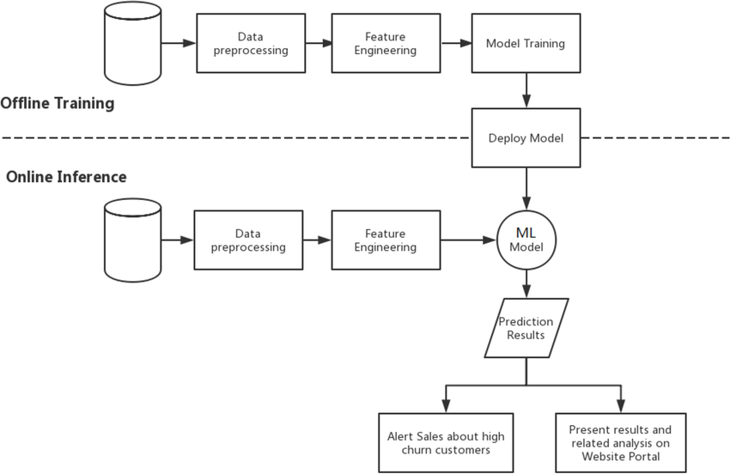
System flowchart

2.2 Product Features
- Data Ingestion and Preprocessing:
  - Import data from CRM systems or upload files (CSV/Excel).
  - Handle missing values and outliers.
  - Encode categorical variables (e.g., account type, region).
  - Normalize numerical features (e.g., account balance, transaction frequency).
- Churn Prediction:
  - Predict churn probability for individual customers.
  - Use supervised machine learning algorithms trained on historical data.
  - Explain predictions using tools like SHAP values to identify key drivers of churn.
- Root Cause Analysis:
  - Identify factors contributing to churn (e.g., high fees, poor customer service).
  - Provide segment-level analysis (e.g., age group, account type).
- Visualization and Dashboards:
  - Interactive charts and graphs showing churn trends.
  - Drill-down views for specific customer segments.
  - Filters to customize visualizations by date, region, or product.
- Recommendation Engine:
  - Suggest personalized retention strategies (e.g., fee waivers, loyalty rewards).
  - Highlight at-risk customers for proactive outreach.
- Reporting Module:
  - Generate reports summarizing churn predictions and insights.
  - Export reports in PDF or Excel format.
  - Include graphs and recommendations for stakeholders.
- Proactive Alert System:
  - Notify managers of high-risk customers.
  - Provide weekly summaries of churn trends and key insights.
2.3 User Classes and Characteristics
- Banking Executives:
  - Require high-level summaries and actionable recommendations.
  - Prefer visual dashboards and automated reports.
- Data Analysts:
  - Use detailed outputs like feature importance and raw predictions for further analysis.
  - Require integration with analytics tools like Jupyter Notebooks.
- IT Administrators:
  - Manage system deployment and maintenance.
  - Ensure data security and system reliability.
2.4 Operating Environment
- Frontend: Web browsers (Chrome, Firefox, Edge).
- Backend: Python with Flask/Django.
- Database: PostgreSQL, MySQL, or MongoDB.
- Machine Learning Frameworks: Scikit-learn, TensorFlow, XGBoost.
- Cloud Hosting: AWS, Azure, or Google Cloud.
2.5 Assumptions and Dependencies
- Banks provide clean and structured historical data.
- The system relies on open-source libraries and frameworks.
- The bank’s CRM and database systems support API integration.

3. Specific Requirements
3.1 Functional Requirements
- Data Upload:
  - Accept data in multiple formats: The system will support data uploads in CSV, Excel, or JSON formats. This ensures compatibility with diverse data sources used by banking institutions.
  - Error logging: Invalid or missing data entries will be flagged and logged. Users will receive detailed error reports to facilitate corrective actions.
- Prediction Module:
  - Model implementation: Multiple machine learning algorithms, including Logistic Regression, Random Forest, and Gradient Boosting (e.g., XGBoost), will be implemented. This allows for model comparison and selection of the best-performing algorithm.
  - Confidence intervals: Predictions will include confidence intervals, providing a probabilistic measure of the churn likelihood.
- Dashboards:
  - Filter options: Dashboards will include filters for attributes like date, region, customer segment, and product type. This enables users to drill down into specific data subsets.
  - Export capabilities: Visualizations such as graphs and charts can be exported in presentation-friendly formats (e.g., PNG, PDF).

- Reports:
  - Churn analysis summaries: Reports will highlight the top factors influencing churn and summarize actionable insights.
  - Exportable formats: Reports will be available in PDF and Excel formats to accommodate various stakeholder needs.
- Alerts:
  - Real-time notifications: Managers will receive alerts about high-risk customers via email or the dashboard notification system.
  - Weekly summaries: Automated weekly updates on churn trends and key metrics will be provided to relevant stakeholders.

3.2 UML diagrams
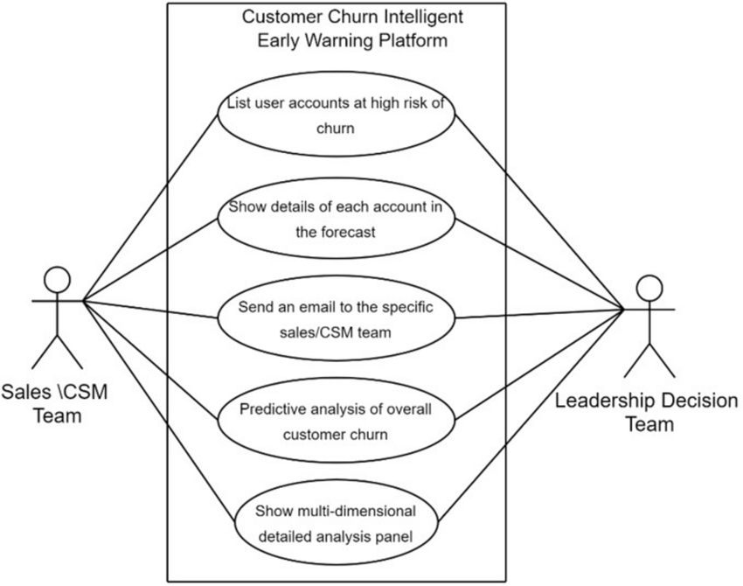

3.3 UML Class Diagram

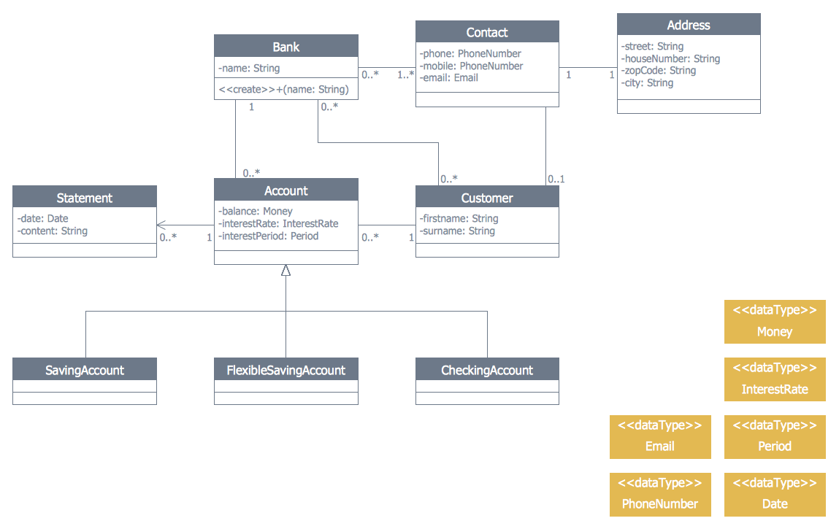
UML class diagram

3.4 Non-functional Requirements
1. Performance
- API Response Time: The system must ensure that all API responses are completed within a maximum of 2 seconds under normal operating conditions. This ensures a smooth user experience and responsiveness.
- Data Handling Capacity: The system must be capable of efficiently handling datasets containing up to 1 million records without significant degradation in performance. Optimization techniques such as indexing, caching, and batch processing should be employed to ensure scalability.
2. Usability
- User Interface Design: The system will feature an intuitive and user-friendly interface to ensure accessibility for non-technical users. This includes clear navigation, meaningful visualizations, and contextual help or tooltips to guide users.
- Accessibility: The design should follow WCAG (Web Content Accessibility Guidelines) to accommodate users with disabilities, ensuring compliance with modern accessibility standards.
3. Reliability
- System Uptime: The system must guarantee 99.9% uptime for cloud-hosted environments, equating to a maximum downtime of approximately 8 hours and 45 minutes per year. This is critical to ensure high availability for end users.
- Error Handling and Recovery: The system should include robust error handling mechanisms to minimize disruptions. In case of failures, automatic recovery processes should be implemented to restore services as quickly as possible.
4. Security
- Data Encryption: All sensitive customer data (e.g., personal information, financial data) must be encrypted using industry-standard encryption protocols such as AES-256 for data at rest and TLS 1.3 for data in transit.
- Compliance: The system must adhere to GDPR (General Data Protection Regulation) and other relevant data protection regulations applicable to the region of deployment. This includes features like obtaining explicit consent from users for data collection, providing the ability to delete user data upon request, and maintaining audit logs for regulatory compliance.
- Authentication and Authorization: Implement secure user authentication mechanisms such as OAuth 2.0 or multi-factor authentication (MFA). Role-based access control (RBAC) should be enforced to ensure that users can only access data and perform actions within their assigned privileges

4. External Interface Requirements
4.1 User Interfaces
- Web-based Dashboards for Managers and Analysts:
The system will provide interactive, web-based dashboards tailored for managers and analysts to monitor, visualize, and analyze data effectively. Key features include:
  - Data visualizations such as charts, graphs, and tables to help users interpret trends and patterns.
  - Export functionality for reports in formats like CSV, PDF, or Excel for offline use.
  - Filters and advanced search options for drilling down into specific datasets or customer segments.
- Admin Panels for IT Administrators:
A dedicated administration panel will be available for IT administrators to manage system settings and user accounts. Key features include:
  - Role-based user management, allowing the creation, deletion, and modification of user roles and permissions.
  - Monitoring tools to track system performance, usage statistics, and error logs.
  - Options for configuring APIs, integrating external systems, and performing backups or restores.
4.2 Hardware Interfaces
- Server Specifications:
The system will require servers with the following minimum specifications to ensure smooth operation and scalability:
  - RAM: At least 8 GB of RAM to handle memory-intensive operations such as data processing and real-time analytics.
  - CPU Cores: At least 4 CPU cores to manage concurrent tasks and support multi-threaded processing efficiently.
  - Storage: High-speed SSDs for faster data access and processing. The storage capacity should be based on expected data volume and include room for future scalability.

4.3 Software Interfaces
- APIs for Integration:
The system will provide robust APIs to facilitate integration with external software systems, ensuring seamless data exchange. These include:
  - Banking CRMs: Integration with customer relationship management (CRM) systems used in the banking sector to import and export customer data, track interactions, and provide insights for better decision-making.
  - Data Warehouses: Direct API connections to data warehouses for efficient retrieval and storage of large-scale datasets, enabling streamlined analytics and reporting.
- Supported Formats and Protocols:
The APIs will support standard data formats like JSON and XML for input and output, and will utilize secure communication protocols such as HTTPS and OAuth 2.0 for authentication.

5. System Models
5.1 Data Flow
1. Import Data from Banking CRM or Upload Files
- CRM Integration: The system will connect to the banking CRM via secure APIs to fetch customer data. The imported data may include customer profiles, transaction histories, interaction logs, and other relevant metrics.
- File Upload Option: Users can also upload datasets manually in commonly supported formats such as CSV, Excel, or JSON. The system will provide validation checks during the upload process to ensure the data conforms to expected formats and schemas.
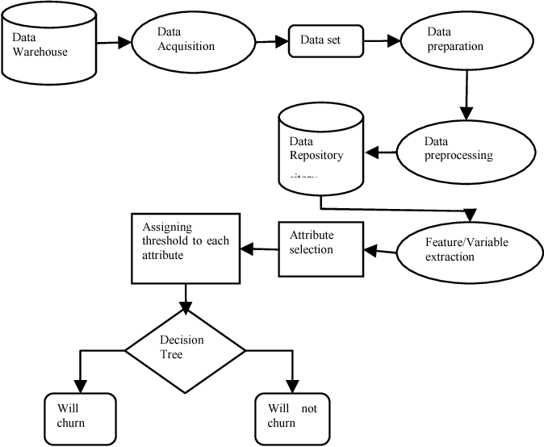
Data flow diagram
2. Preprocess Data for Analysis
- Data Cleaning: Raw data will undergo preprocessing steps to handle missing values, detect and correct inconsistencies, and remove duplicates.
- Feature Engineering: Key features relevant to churn prediction, such as customer behavior patterns, transaction frequencies, and service usage, will be extracted or engineered for model training.
- Normalization and Transformation: Data will be normalized or transformed as needed to make it suitable for machine learning algorithms. For example, categorical data will be converted into numerical formats through techniques like one-hot encoding.
3. Train Machine Learning Models
- Model Selection: The system will utilize pre-built machine learning algorithms (e.g., logistic regression, random forest, or XGBoost) optimized for churn prediction. Advanced users may also have the option to select or customize algorithms.
- Training Process: The system will split the data into training and testing subsets and train the models using historical data. Hyperparameter tuning will be performed to optimize the model’s performance.
- Model Validation: The trained model’s performance will be evaluated using metrics such as accuracy, precision, recall, and F1-score. Cross-validation techniques will ensure the robustness of the results.
4. Predict Churn and Generate Insights
- Churn Prediction: Once trained, the machine learning model will predict the likelihood of customer churn based on the latest customer data.
- Actionable Insights: The system will generate insights such as:
  - Customer segments at the highest risk of churn.
  - Key factors contributing to churn for different customer groups (e.g., low product usage, poor customer service).
  - Recommendations for retention strategies, such as offering personalized discounts or improving specific services.
5. Visualize Results in Dashboards and Reports
- Dashboards: The results of the churn predictions and insights will be visualized in dynamic dashboards for easy interpretation. Features include:
  - Interactive graphs, charts, and heatmaps showing churn trends and high-risk customer groups.
  - Drill-down capabilities for managers to explore individual customer profiles or segments.
- Reports: Automatically generated reports summarizing churn predictions and insights will be available for download in formats such as PDF or Excel. These reports can be customized to include specific metrics or visualizations based on user requirements.
5.2 Key Algorithms
1. Logistic Regression for Baseline Predictions
- Purpose: Logistic regression will serve as the baseline model for churn prediction. It is a simple yet effective algorithm for binary classification tasks, such as predicting whether a customer will churn (1) or not churn (0).
- Working Principle: The algorithm predicts the probability of churn by estimating the relationship between customer features (e.g., age, transaction history, usage patterns) and the likelihood of churn. It uses the logistic function to output probabilities, which are then classified into churn or non-churn categories based on a threshold (typically 0.5).
- Advantages:
  - Quick and easy to implement.
  - Provides interpretable coefficients, allowing for a clear understanding of how each feature impacts churn predictions.
  - Suitable for scenarios where the relationship between features and the target is approximately linear.
- Use Case: This model will be used to establish a benchmark for other more complex models. Its simplicity makes it useful for quick, initial predictions when resources or time are limited.
2. Random Forest for Interpretable Insights
- Purpose: Random forest, an ensemble learning technique, will be used to predict churn while also providing interpretable insights into the key factors contributing to churn.
- Working Principle: Random forest creates a collection of decision trees (hence, "forest"), each trained on random subsets of the data and features. The predictions of these trees are aggregated (usually through voting) to make the final prediction.
- Advantages:
  - Robustness: Random forest handles overfitting better than individual decision trees by averaging the results of multiple trees, reducing variance.
  - Feature Importance: One of the main advantages of random forest is its ability to calculate the importance of each feature in making predictions. This allows us to understand which customer characteristics (e.g., frequency of interactions, product usage) are the most important drivers of churn.
  - Handles Non-linearity: It can capture complex, non-linear relationships between features and the target variable.
- Use Case: Random forest will be used when interpretability and understanding the key drivers of churn are crucial. It is also suitable for data with complex, non-linear relationships between features.
3. Gradient Boosting Models (e.g., XGBoost) for High Accuracy
- Purpose: Gradient boosting models, particularly XGBoost, will be used to maximize accuracy in churn prediction. These models build trees sequentially, where each tree tries to correct the errors of the previous one.
- Working Principle: XGBoost uses gradient boosting, a technique that focuses on training models that correct the residual errors (differences between predicted and actual outcomes) from prior models. Each subsequent model is trained on the errors made by previous models, improving predictive performance with each iteration.
- Advantages:
  - High Accuracy: XGBoost typically provides higher predictive accuracy than other algorithms by focusing on reducing bias and variance.
  - Handling Missing Data: It has built-in mechanisms to handle missing data effectively without the need for imputation.
  - Regularization: XGBoost includes regularization (L1 and L2) to prevent overfitting, ensuring good generalization.
- Use Case: XGBoost will be used when the primary objective is achieving the highest predictive accuracy, especially when the dataset contains large amounts of data and complex relationships between features.
4. Neural Networks for Complex Patterns
- Purpose: Neural networks, especially deep learning models, will be employed to detect complex, non-linear patterns in the data that might not be captured by traditional machine learning models.
- Working Principle: Neural networks consist of layers of interconnected nodes (neurons) that transform the input data through non-linear activation functions. In a deep neural network, multiple layers allow the model to learn increasingly abstract features of the data. The model is trained using backpropagation to adjust weights and minimize prediction errors.
- Advantages:
  - Learning Complex Patterns: Neural networks excel at capturing highly complex and non-linear relationships in large datasets, making them suitable for tasks where traditional models might struggle.
  - Scalability: Neural networks can handle very large datasets, making them effective for big data applications.
  - Flexibility: Neural networks can be adapted for different types of problems (e.g., classification, regression) and can incorporate a wide variety of data types, such as text or images, if needed in future use cases.
- Use Case: Neural networks will be used for situations where complex, non-linear relationships or large-scale datasets require more advanced methods. This model is particularly useful if the data contains intricate patterns that simpler algorithms might not detect.

6. Appendices
6.1 Glossary
- Churner: A customer who is likely to discontinue their banking services with the institution. This can include closing accounts, reducing usage, or switching to a competitor.
- Predictors: Independent variables that are believed to influence customer churn. These can include various factors such as:
  - Account Balance: The amount of money held in the customer's accounts.
  - Transaction Frequency: The number and type of transactions (e.g., deposits, withdrawals, transfers) performed by the customer within a specific timeframe.
  - Customer Demographics: Age, gender, location, occupation, etc.
  - Product Usage: Utilization of various banking products (e.g., credit cards, loans, online banking, mobile banking).
  - Customer Service Interactions: Frequency and nature of interactions with customer service (e.g., complaints, inquiries).
  - Tenure: Length of time the customer has been with the bank.

6.2 References
- Scikit-learn: https://scikit-learn.org/stable/
- Tensorflow documentation: https://www.tensorflow.org/api_docs
- Bank Customer Churn Prediction Using Machine Learning: https://www.analyticsvidhya.com/blog/2022/09/bank-customer-churn-prediction-using-machine-learning/

